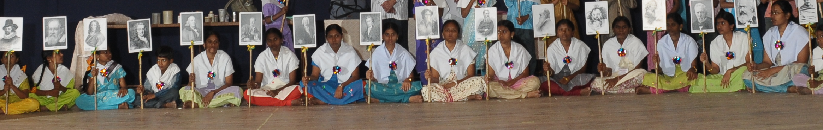
Invitation
9th World Atheist Conference
Organized by Atheist Centre, Vijayawada, INDIA
January 6 & 7, 2016
Venue: Siddhartha College of Arts & Science, Vijayawada, Andhra Pradesh, INDIA
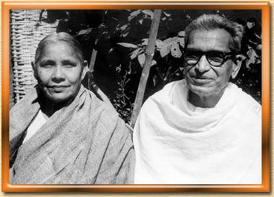
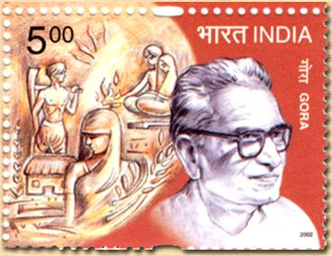
Atheism is a way of life

Welcome to the historic 9th World Atheist Conference organized on the eve of the Platinum Jubilee of the

Atheist Centre
The Beginning:
The world’s first known Atheist Centre was founded by Gora (1902-1975) and Saraswathi Gora (1912-2006) in 1940 at Mudunuru of Krishna District of Andhra Pradesh, India.
On the eve of the independence, Atheist Centre was shifted to Vijayawada, currently the capital of Andhra Pradesh. It has since been the hub of activity for promotion of atheism, humanism and social change. Atheist Centre as a social change organization has been paving the way to build atheism as an alternative way of life/life stance and positive atheism as a philosophy. Gora and Saraswathi were close associates of Mahatma Gandhi and the nationalist movement. They participated in the freedom struggle. Gora’s discussion with Gandhi on atheism and social change were published in a book titled, ‘An Atheist with Gandhi’, by Navajivan Publishers. Even in the post-Gandhian period, Atheist Centre was also closely associated with the Bhoodan Movement of Vinobha Bhave and other Gandhian non-violent and peace building movements in India. Atheist Centre is in the mainstream of national life, maintaining its distinctive position with its non-religious, humanist and atheist approach. Atheist Centre carriers its multifarious activities with the cooperation and good will of people. The secular social work and popular science activities are carried out through Arthik Samata Mandal, Samskar, Vasavya Mahila Mandali and Gora Science Centre and research through Gora & Saraswathi Gora International Atheist Research Centre.
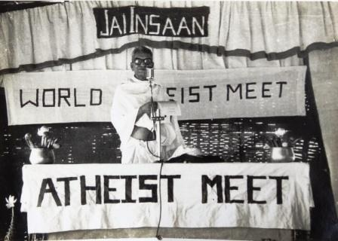
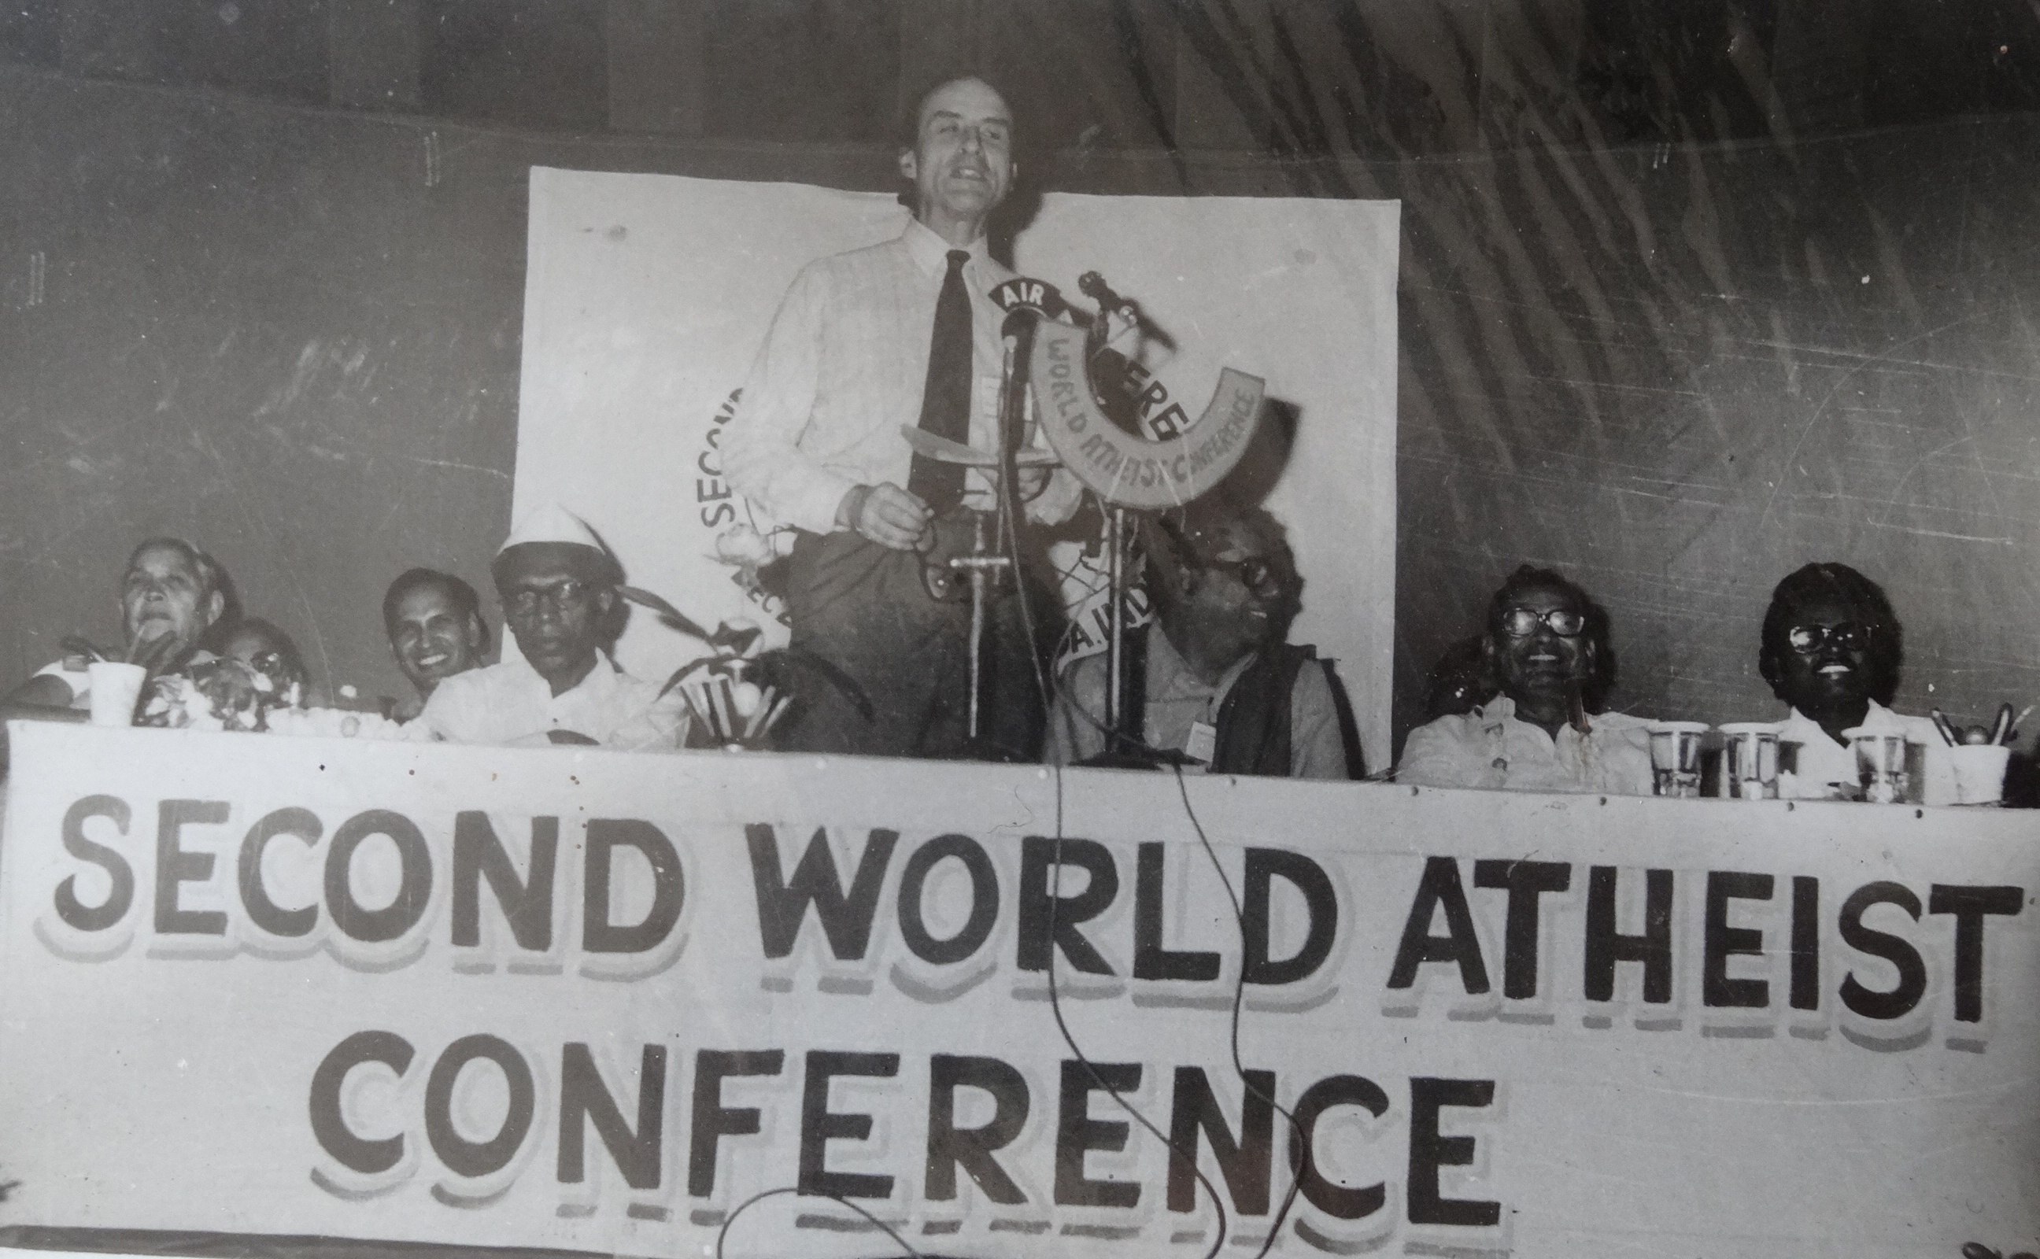
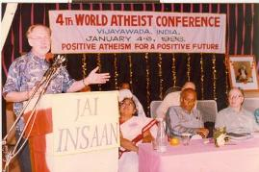
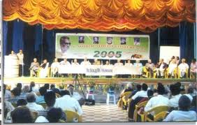
Conferences & Seminars:
Over the period of 75 years, Atheist Centre organized many conferences, seminars and secular social work activities. Hundreds of people and speakers from India and abroad participated in the workshops, conference, atheist study camps, seminars and outreach programmes. A great opportunity to share notes, learning and social experiments that would help to build scientific temper, spirit of inquiry, reform and promotion of atheism and humanism as a life stance and secular thought and action.
So far, Eight World Atheist Conferences (WAC) were organized: I-WAC: Dec. 22-26, 1972, Atheist Centre, Vijayawada; II-WAC: Dec. 25, 1980, Atheist Centre, Vijayawada; III-WAC: June 24-27, 1983, Helsinki, Finland; IV-WAC: Jan 4-6, 1996, Atheist Centre, Vijayawada. Theme: Positive Atheism for a Positive Future; V-WAC: Jan 7-9, 2005: Atheist Centre. Theme: Atheism & Social Progress; VI-WAC: Jan 5-7, 2007, Atheist Centre, Vijayawada. Theme: The Necessity of Atheism; VII-WAC: Jan 5-7, 2009, Atheist Centre, Vijayawada. Theme: March of Atheism and VIII-WAC: Jan 7-9, 2011, Trichy, Tamil Nadu. Theme: Atheism – An Alternative Culture.
Awards & Recognition:
Over the years, the founders and members of Atheist Centre received many laurels for their work in promoting atheism, humanism, social change and reform. Some of them include: International Humanist Award, Jamnalal Bajaj National Award, Jankidevi Bajaj National Award, G.D. Birla International Award for promotion of humanism, Karnataka Government’s the very first Basava National Award for promotion of castelessness. In 2002, the Government of India released a commemorative postage stamp on Gora, as an atheist social reformer.
Atheism as a way of life:
Atheist Centre promotes atheism as a way of life and scientific temper and spirit of inquiry to build a rational society. It strives to strengthen the secular ramparts we guard and stands for the freedom of expression and the right to question. It works for the rights of the marginalized through integrated development of the society by building alternatives and through secular social work.
The 75 years of the journey of the Atheist Centre was possible with the support and goodwill of the like-minded individuals, government, media and the global community. We thank you all for support and look forward to your participation in the 9th World Atheist Conference.
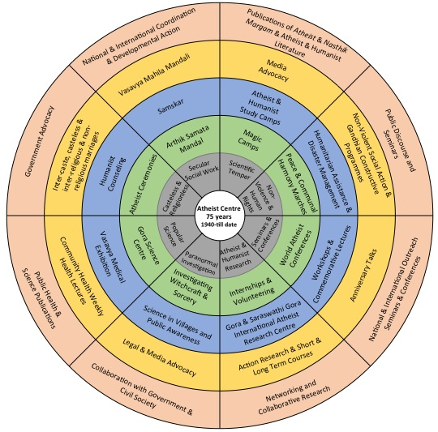

75 YEARS OF ATHEIST CENTRE
The journey continues….
1902-1912: Birth of Atheist Social Reformers
1913-23: Early Life, Marriage & Education
1923-34: Dismissals in India & Sri Lanka, becoming Atheists & challenging blind beliefs, beginning of social reform activities.
1935-45: Starting of Atheist Centre, fight against superstitions and untouchability, Gandhi-Gora Conversations, Freedom Struggle & Satyagrahas.
1946-56: Newsletter, Bhoodan Movement.
1957-67: Vasavya Experimental School, Partyless candidate, satyagrahas, scientific outlook promotion in villages.
1968-78: Food Security Movement, international tours, First World Atheist Conference, Gora’s demise.
1979-89: Second & Third World Atheist Conferences, Unity Marches and Disaster Relief.
1990-2000: Golden Jubilee, Fourth World Atheist Conference.
2001-2006: Gora’s Birth Centenary & Commemorative Postage Stamp, demise of Saraswathi Gora.
2007-2014: Sixth, Seventh, Eight World Atheist Conferences, Saraswathi Gora Birth Centenary, Golden Jubilee of Gora Science Centre, starting of Gora & Saraswathi Gora International Atheist Research Centre.

9th World Atheist Conference
In the light of the growing fundamentalism, human rights violations and injustice and erosion of secular values in the world, there is a need to strengthen an alterative voice for a secular, post-religious society based on scientific outlook and rational thought & action. Many humanist and atheist and like-minded organizations and individuals around the world are fighting against marginalization, fundamentalism, religious atrocities and a plethora of human rights and development related issues.
The Conference will bring people from across the world and pan India. Atheists, humanists, skeptics, freethinkers, social workers, reformers, scientists, academicians, media and government representatives will attend this historic conference.
The conference will be yet another occasion to share the work and build a potential force of collection action to uphold scientific temper and secular outlook in the society.
The conference will have plenary sessions with distinguished speakers and activists, followed by focus group discussions on atheism & humanism as a life stance, investigating claims of the paranormal, social justice & human rights, religious fundamentalism, humanist youth leadership, secular social work etc.
Registration:
The Conference registration fee is Rs. 500 for Indians and USD 100 for foreigners. The fee may be remitted through a Crossed Demand Draft on any bank favouring, ‘Atheist Centre’ payable at Vijayawada. You can also send donations. Cash payment on arrival, at the registration desk is also possible. The fee would cover food and humble accommodation at Atheist Centre. Due to rush and limited accommodation, kindly send your request at the earliest. Write to positiveatheist@gmail.com with your details for further information on the conference and any questions you have for us.

The Venue:
Vijayawada is situated on the southern banks of River Krishna, in the Krishna District of Andhra Pradesh. The city has a population of 1,048,240 (2011 census). Vijayawada is the capital of the newly formed state of Andhra Pradesh. It is well connected by road, air and rail and has the second biggest railway junction in India. The venue of the conference is: Siddhartha Auditorium. It is located less than 5 kilometers by auto rickshaw/taxi from Vijayawada Railway Station and 20 kilometers from the Vijayawada Airport. It is one kilometer from Atheist Centre.
By Air: www.makemytrip.com
By Road: http://www.travelyaari.com/travels/and hrapardesh_apsrtc.html
By Train: www.irctc.gov.in and www.indianrail.gov.in and
Hotels: http://aptdc.in/vijayawada/accommodation.php

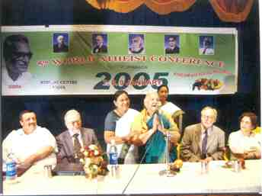
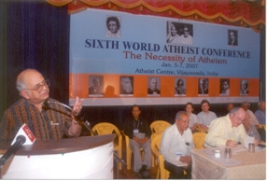
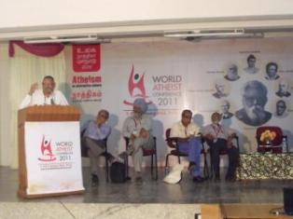
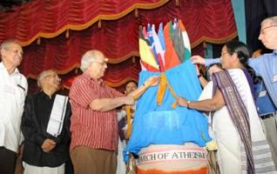
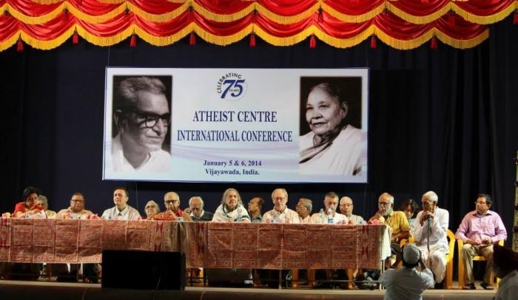
Atheist Centre
Benz Circle, Vijayawada, Andhra Pradesh
INDIA; Ph: +91 866 2472330
Email: positiveatheist@gmail.com; Website: www.atheistcentre.in
Facebook: positiveatheism
Conference Conveners:
Dr. G. Vijayam, Dr. Samaram, Dr. Maru, Mr. Niyantha & Mr. Vikas Gora

We seek your cooperation, support and wider outreach. Detailed schedule will follow soon.

